STATISTICS CONSULT FORM
Requestor
Hiroe Hu, Owen Brown, Jess Sloane
Senior staff member associated with project (if applicable)
Elizabeth Ballard, Peixoing Yuan
Project name
Measuring Plasma Oxytocin and Neurophysin I (surrogate marker for oxytocin) pre/post-ketamine
Level of support
Background: What is already known about this topic?
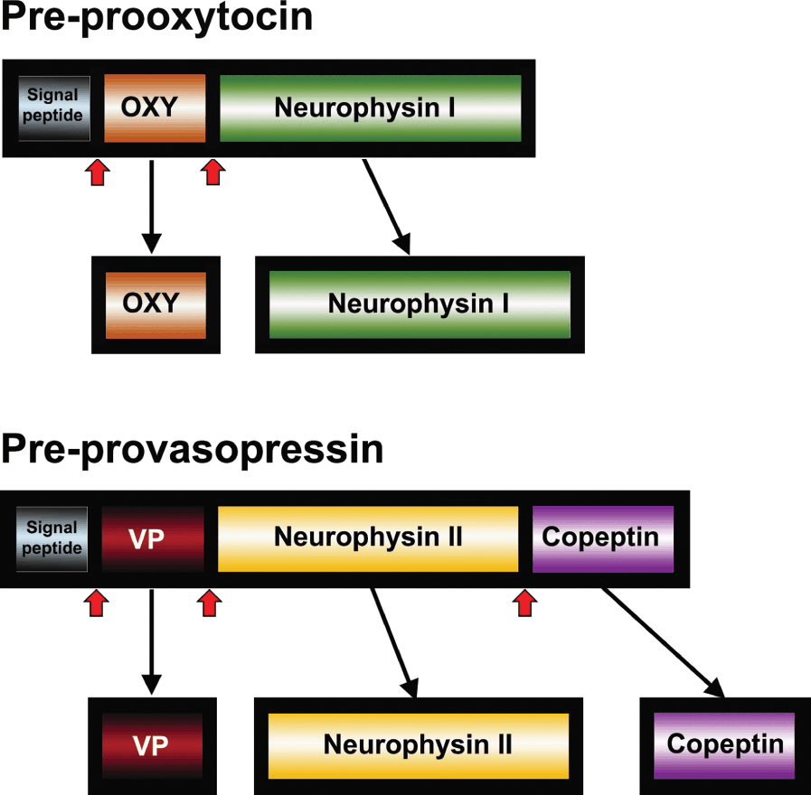
Endogenous oxytocin (OXT) is a small peptide that is difficult to measure in human plasma due to its size, resulting in inconsistent measurement with commonly used assays (Leng & Sebatier, 2016; Tabak et al., 2022). Single baseline plasma OXT measurements show substantial intra-individual variability and poor test-retest reliability, undermining their use as trait markers and shifting the field toward longitudinal and state-sensitive measurement of OXT (Martins et al., 2020; Engel et al., 2019). Liquid chromatography-mass spectrometry (LC-MS) is the benchmark for OXT quantification because it compensates for the size of the peptide by directly identifying molecular mass and structure. However, LC-MS remains resource-intensive, requires careful standardization, and is therefore not scalable for large clinical trials (Tabak et al., 2022). Neurophysin I (NP-I), a cleavage product of the oxytocin precursor that is co-released in equal molar amounts with OXT, offers a candidate surrogate marker because it is larger, more stable, and measurable with sandwich ELISAs that are less susceptible to the limitations affecting OXT assays (Atila et al., 2023; Tabak et al., 2022). Under conditions of significant oxytocin release, such as MDMA provocation, NP-I demonstrates strong correlations with plasma OXT, suggesting that NP-I can index biologically meaningful OXT secretion (Atila et al., 2023). Although NP-I has been validated as a reliable surrogate marker for OXT in healthy volunteers and patients with Central Diabetes Insipidius, no studies have yet validated NP-I as a reliable surrogate marker for OXT in patients with depression.

Beyond measurement considerations, it is also important to identify clinically meaningful symptom clusters that may be sensitive to OXT and NP-I levels and treatment response (such as from ketamine). Social anhedonia, defined as reduced pleasure derived from social interactions, is recognized as a symptom domain that is distinct from physical anhedonia and not fully explained by overall depression symptom severity (Gandhi et al., 2022). Reverse-translational and clinical studies demonstrate that social-affective processes, such as pleasure from affiliative interactions, are pharmacologically modifiable with ketamine, and they better reflect the engagement of state-dependent social-affective neural circuitry rather than static trait-based mood characteristics (Hess et al., 2024; Nardou et al., 2019). To assess pleasure derived from social interactions, a relevant subscale can be attained from the Snaith-Hamilton Pleasure Scale (SHAPS). The SHAPS is a subjective measure of hedonic tone that includes items assessing pleasure derived from social interactions, including closeness with others, helping others, and receiving social approval. Prior work demonstrates that these social interaction SHAPS items are sensitive to modulation via the rapid action of ketamine and can change over short time periods in a manner consistent with state-dependent social-affective processing (Hess et al., 2024; manuscript by Hu et al. in preparation).

No prior clinical trials have measured pre/post-ketamine OXT or NP-I levels, particularly in relation to antidepressant and/or social hedonic response. However, rodent models demonstrate that ketamine activates the oxytocinergic system (Edem et al., 2023). Oxytocin activity has been implicated in social salience, social reward learning, and adaptive social behavior (Ma et al., 2016). Low oxytocin activity has also been implicated in low social quality of life and vulnerability to loneliness in MDD (Tang et al., 2019; Tsai et al., 2019). However, the limitations and instability of peripheral OXT measurements complicate efforts to directly link OXT to the subjective social-affective symptom cluster and treatment response (Leng & Sabatier, 2016; Martins et al., 2020; Tabak et al., 2022). NP-I by virtue of its equimolar co-release with OXT, may also provide a measure of oxytocin system engagement in relation to social anhedonia and its treatment response to ketamine.

Although both OXT and NP-I may reflect activity of the oxytocin system, they differ substantially in their analytic properties and potential utility as biomarkers. Direct OXT measurement is constrained by rapid clearance, pulsatile secretion, and assay-related variability, which may obfuscate observable associations with behavior or subjective symptom scales, particularly in cross-sectional analyses (Leng & Sabatier, 2016; Martins et al., 2020). In contrast, NP-I demonstrates a larger and more dynamic range, along with strong correlations with OXT under pharmacologic provocation (Atila et al., 2023). This suggests it may more reliably capture state-sensitive, and therefore more clinically meaningful oxytocin-related variance, particularly in response to treatment. Given evidence that social anhedonia is state-sensitive and responsive to pharmacologic modulation with ketamine (Hess et al., 2024), it is important to determine not only whether OXT and NP-I are individually associated with subjective social anhedonia-related symptoms, but also whether NP-I demonstrates stronger and/or more reliable associations with these symptoms than OXT itself. Together, this body of work motivates evaluation of NP-I and OXT as candidate biomarkers of social-affective system engagement, using validated subjective measures of social pleasure, i.e. SHAPS-derived measures, as clinically relevant outcomes.

Research question(s)
- In Neurobiology of Suicide participants, to what extent do plasma Neurophysin I concentrations, measured by ELISA, correlate with plasma oxytocin concentrations measured by LC-MS?

- To what extent are plasma OXT concentrations and plasma NP-I concentrations associated with subjective improvement in social anhedonia from ketamine? Does an increase in OXT and/or NP-I post-ketamine predict an improvement in social anhedonia?

- Does plasma Neurophysin I demonstrate stronger and/or more reliable associations with social anhedonia-related SHAPS items than plasma oxytocin?
- Are there dose-dependent effects of ketamine on plasma OXT/NP-I levels?
Hypotheses
Must be testable and falsifiable (i.e., include directionality). Must follow from your background/theory and questions.

Hypothesis #1: NP-I as a surrogate for OXT (concurrent validity)

We hypothesize that plasma Neurophysin I (NP-I) will correlate positively with plasma oxytocin (OXT) measured by LC-MS, and that within-subject changes in NP-I (post–pre ketamine) will track within-subject changes in OXT.
- H1.1 Across participants and timepoints, plasma NP-I will be positively associated with plasma OXT (LC-MS).
- H1.2 Within individuals, time-varying NP-I will track time-varying OXT (i.e., within-person deviations in NP-I from a person’s mean will be associated with within-person deviations in OXT).

Hypothesis Set 2: Ketamine-related biomarker changes predict symptom changes

We further hypothesize that ketamine-related increases in NP-I will predict improvement in social anhedonia (SHAPS-derived social items), and that these associations will be stronger and more reliable for NP-I than for OXT with symptom-specificity to social anhedonia.
- H2.1 Time-varying NP-I will be associated with time-varying SHAPS_social (greater NP-I corresponding to better social hedonic tone), consistent with ketamine-linked oxytocin system engagement.
- H2.2 NP-I will show stronger associations with SHAPS_social than with nonsocial/physical SHAPS items.
- H2.3 NP-I will show preferential association with SHAPS_social relative to MADRS, and will explain unique variance in SHAPS_social beyond concurrent MADRS severity.

Hypothesis Set 3: Dose-dependent effects
- H3.1 NP-I levels will vary as a function of infusion number (dose/exposure).
- H3.2 Infusion number will moderate the NP-I ↔ SHAPS_social association (progressive engagement).
- H3.3 Individuals with greater longitudinal increases in NP-I across infusions will show steeper longitudinal improvement in SHAPS_social.
Data you require to test your hypotheses
Operationalize the variables in your hypotheses. If the dataset does not already exist, what is your collection plan? If you have done exploratory data analysis already, please attach to your request.
Biomarker dataset (long format; one row per subject × infusion × timepoint):
- SubjectID
- InfusionNumber (1–5)
- Timepoint (categorical)
  - Infusion #1: -60min, +230min, +24hr
  - Infusion #2–5: -60min, +230min (subset of patients only)
- OXT_LCMS (plasma oxytocin concentration)
- NPI_ELISA (plasma Neurophysin I concentration)
- Assay metadata (if available):
  - batch/plate (LCMS_batch, ELISA_plate)
  - run date
  - replicate info / QC flags
Clinical outcomes dataset (aligned by subject and timepoint relative to infusion):
- SHAPS_total
- SHAPS_social
- SHAPS_nonsocial (derived comparator subscale)
- MADRS_total
- Dates/timestamps (or visit labels) that allow alignment to the exact infusion and biomarker draw
Covariates / design variables:
- demographics: Age, Sex, BMI
- clinical: baseline severity (baseline MADRS; baseline SHAPS_social)
- Diagnosis strata (MDD vs. BD +/- PTSD comorbidity)
- Concomitant psychotropic medication (yes/no)
- cohort indicator: RISC_draw / “has blood draw during repeated infusions” flag
Primary biomarker transforms (based on distribution):
- logNPI = log(NPI_ELISA+N)
- logOXT = log(OXT_LCMS+N)
Dose exposure variables:
- CumulativeInfusions (1–5)
- For repeated-infusion analyses: indicator for “has repeated-infusion biomarker draws” to characterize missingness.

Data collection plan
- Create a master long-format analysis dataset by merging, PER ROW:
  - SubjectID × InfusionNumber × Timepoint
    - Timepoints include: -60, +230, and +24h (infusion #1 only); for infusions 2–5: -60, +230 where available.
  - LC-MS OXT results
  - ELISA NP-I results
  - infusion administration table (dates/times, infusion number)
  - SHAPS + MADRS assessment table (Cristan has this)
Analytic plan (this can be completed with assistance of stats team)

Exploratory data analysis:
- distributions (histograms) for OXT and NP-I (raw + log)
- missingness table by infusion/timepoint (especially infusion 2–5)
- scatterplots NP-I vs OXT (spearman correlation at each time point; gamma distribution for non-normal distributions vs repeated measure correlation using log-transformed values, depending on distribution patterns)
- spaghetti plots for NP-I and OXT over time/infusions for subjects with repeated draws

Primary modeling strategy: use linear mixed-effects models with random subject intercepts to leverage all repeated measures, handle unbalanced infusion counts (1–5), and avoid instability of change scores.
Because repeated-infusion blood draws are incomplete, primary analyses will:
- focus on infusion #1 as the most complete dataset (primary),
- then extend to all available infusions using LMMs (secondary),
- and report missingness patterns

1) NP-I as surrogate of OXT (H1)
To test H1.1: Across participants and timepoints, plasma NP-I will be positively associated with plasma OXT (LC-MS) → model OXT as outcome (both between-subject and within-subject)
- log(OXT) ~ log(NP-I) + Timepoint + InfusionNumber + (1|SubjectID)
To test H1.2 Within individuals, time-varying NP-I will track time-varying OXT (i.e., within-person deviations in NP-I from a person’s mean will be associated with within-person deviations in OXT) → isolate within-person tracking, use person-mean centering to evaluate “Does NP-I track OXT dynamically within people?”
- log(NP-I) = NP-I_within + NP-I_between
where NP-I_within = NP-I - mean of (NP-1) across all timepoints
And fit:
- log(OXT) ~ NP-I_within + NP-I_between + Timepoint + InfusionNumber + (1|SubjectID)

2) Biomarkers predicting social anhedonia (H2/H3)
To test:
- H2.1 Time-varying NP-I will be associated with time-varying SHAPS_social (greater NP-I corresponding to better social hedonic tone), consistent with ketamine-linked oxytocin system engagement.
- H2.3 NP-I will show preferential association with SHAPS_social relative to MADRS, and will explain unique variance in SHAPS_social beyond concurrent MADRS severity.
Outcome: SHAPS_social
- SHAPS_social ~ log(NP-I) + Timepoint + InfusionNumber + MADRS_it + covariates + (1|SubjectID)
Key tests: NP-I effect controlling for MADRS (H2.4)
To test H2.3 NP-I will show stronger associations with SHAPS_social than with nonsocial/physical SHAPS items; Symptom specificity:
- Repeat with SHAPS_nonsocial as outcome
3) Dose moderation
Because repeated-infusion blood draws are incomplete, the dose models should be explicit about missingness.
To test H3.1 NP-I (and/or OXT) levels will vary as a function of infusion number (dose/exposure) → Dose → biomarker?”
- logNPI ~ InfusionNumber + Timepoint + (1|SubjectID)
To test H3.2 Infusion number will moderate the NP-I ↔ SHAPS_social association (progressive engagement) → Dose moderates biomarker–symptom coupling (H4.2):
- SHAPS_social_it ~ log(NP-I_it) × InfusionNumber + Timepoint + MADRS_it + (1|SubjectID)
Primary interpretive target: interaction term.
To test H3.3 Individuals with greater longitudinal increases in NP-I across infusions will show steeper longitudinal improvement in SHAPS_social → For subjects with ≥2 infusions with draws: random-slope model:
- SHAPS_social ~ InfusionNumber + logNPI + (InfusionNumber|SubjectID)

Power (this can be completed with assistance of stats team)
Because this study includes repeated measures, unequal numbers of infusions (1–5), and incomplete biomarker sampling for infusions 2–5, analytic power will depend on:
(1) number of participants with infusion #1 complete draws (-60/+230 and +24h),
(2) number with repeated-infusion draws,
(3) within-subject correlation (ICC) for biomarkers and outcomes, and
(4) missingness mechanisms.
Power approach we propose:
- For Hypothesis Set 1 (NP-I ↔ OXT correlations): compute detectable correlation given N at each timepoint; primary focus infusion #1 and pooled -60/+230min samples.
- For Hypothesis Sets 2–4 (mixed-effects models): use simulation-based power for LMMs (using observed ICC, variance, and missingness patterns) to estimate the minimum detectable standardized effect for:
  - ΔNP-I → ΔSHAPS_social (main effect)
  - ΔNP-I × InfusionNumber interaction (dose moderation)
Primary power target:
- Ensure adequate power for the infusion #1 acute window (most complete data), with repeated-infusion analyses considered secondary/exploratory unless sample sizes support stable interaction estimates.
Timeline: Are there any abstract deadlines?
Other Considerations (please answer all below questions)

Were previous analyses done?

What studies will be included?

What subjects will be included (only MDD? MDD and Controls?)?

Are there possible confounding variables?

What variables should be controlled for in models (common covariates include age, sex, bmi, baseline measures)

Any other complicating factors (study design issues, messy data)?

